**Section Review**  
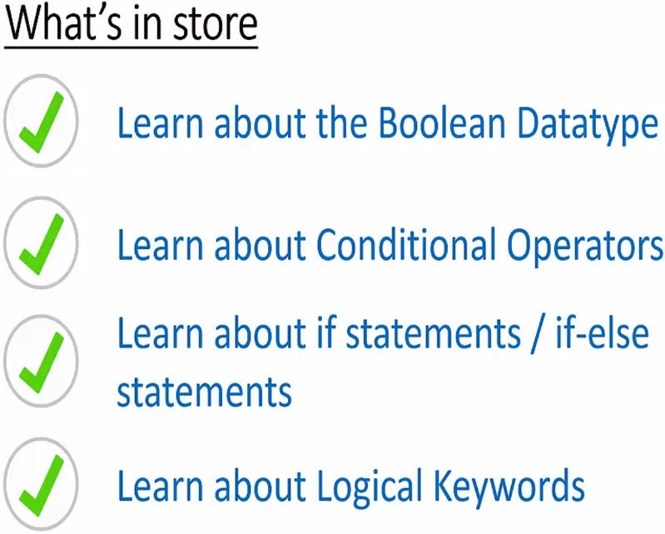

**Booleans & Comparison Operators**  
* Booleans are the building blocks of logic systems.  
* **Boolean**: **True/False**.  
  
**>  
>=  
<  
<=**  
**== Equality Operator  
!=**

**Quiz 4: Comparison Operators Quiz**

**if Statements**  
**if condition :**  
* **NESTING**  
**elif  
else**  
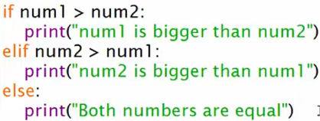

**Coding Exercise 9: If Statements Challenge**

**Python Logical Operators - Part 1 - not + and**  
**not**  
  
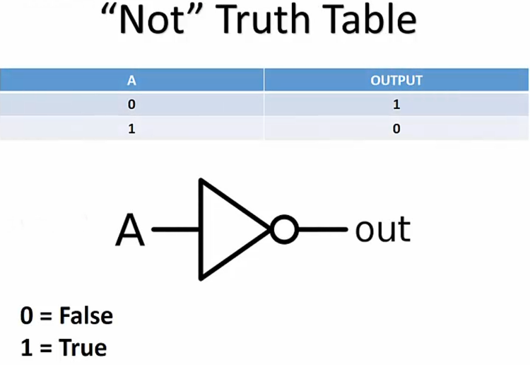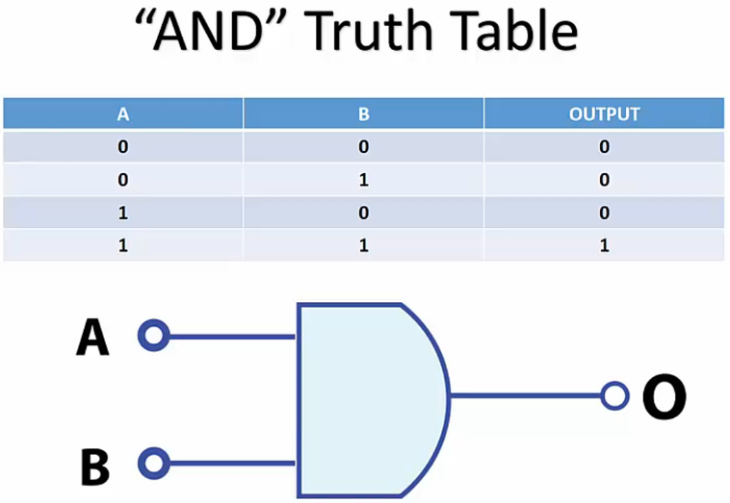  
**Python Logical Operators - Part 2 - or operator**  
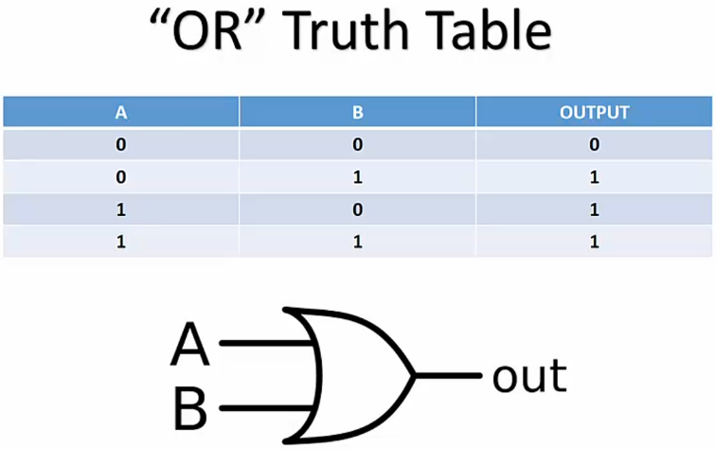

**Quiz 5: Logical Operators Quiz**

**Section Review**